Programs: Electrical & Computer Engineering

|  |  |
| --- | --- |
| Course Number | **COE608** |
| Course Title | **Computer Architecture** |
| Semester/Year | **Winter 2019** |
| Instructor | **Naimul Khan** |
| FLC | **Alagan Anpalagan** |

|  |  |
| --- | --- |
| **Lab Report No.** | **2** |

|  |  |
| --- | --- |
| Report Title | **Program Counter and Register Set Design** |

|  |  |
| --- | --- |
| Section No. | **04** |
| Group No. |  |
| Submission Date | **31/01/19** |
| Due Date | **31/01/19** |

|  |  |  |
| --- | --- | --- |
| Name | Student ID | Signature* |
| Vatsal Shreekant | 71363 |  |

(Note: remove the first 4 digits from your student ID)

*\*By signing above you attest that you have contributed to this submission and confirm that all work you have contributed to this submission is your own work. Any suspicion of copying or plagiarism in this work will result in an investigation of Academic Misconduct and may result in a “0” on the work, an “F” in the course, or possibly more severe penalties, as well as a Disciplinary Notice on your academic record under the Student Code of Academic Conduct, which can be found online at:*

[*www.ryerson.ca/senate/current/pol60.pdf*](http://www.ryerson.ca/senate/current/pol60.pdf)*.*

***Register 32 bit code:***

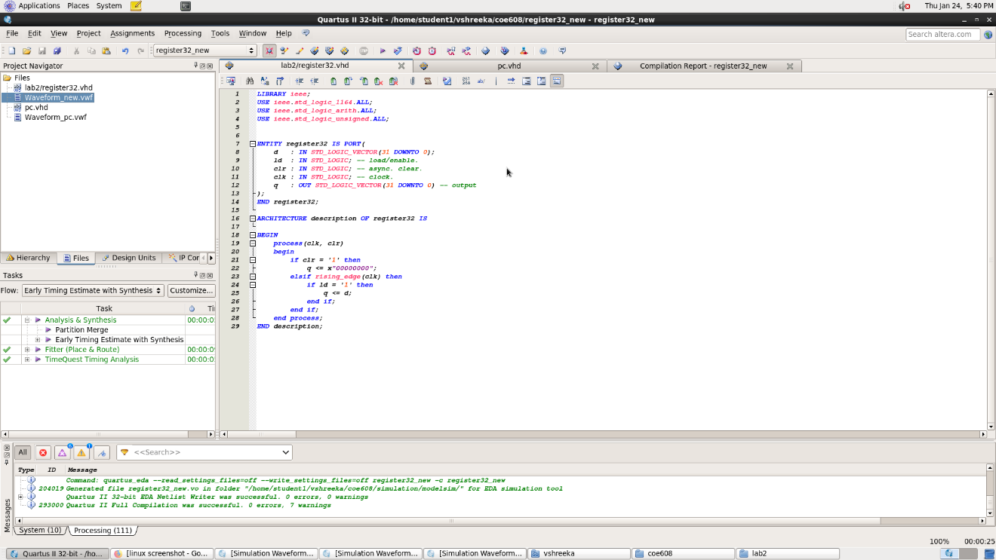

***Waveform for Register 32 bit:***

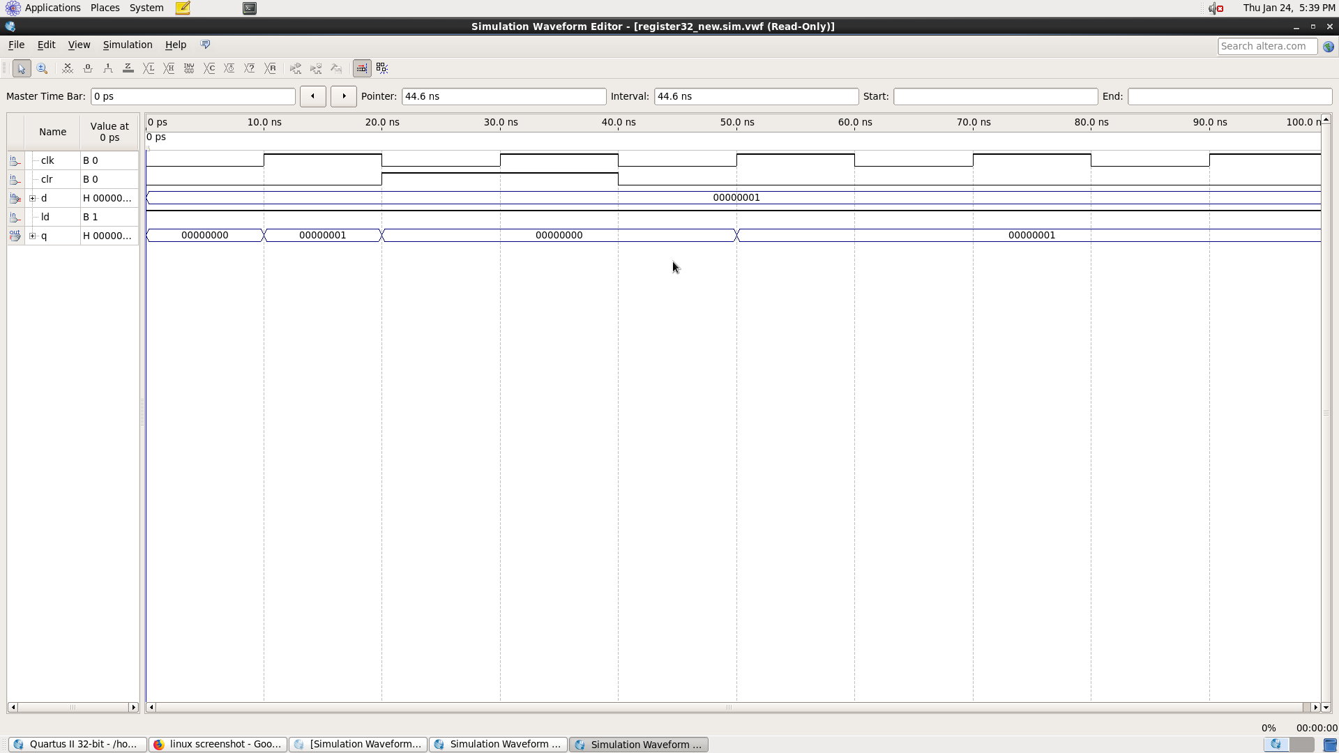

***Program Counter code:***

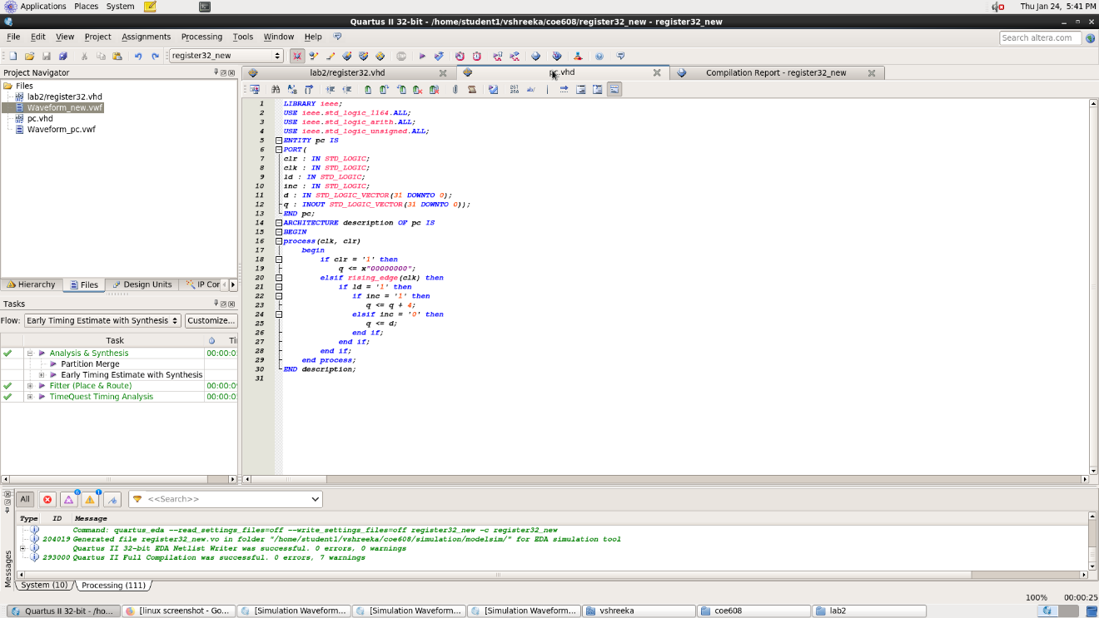

***Waveform for Program Counter:***

